DHCP - Worksheet

- As you work through the project, complete the network documentation sheet. The current access passwords have been included. Change and document all passwords. Create different passwords for each device and function. For IP addresses, if device receives address from DHCP, type DHCP. If statically assigned, type the IP Address | Points Possible | Points Awarded
 | 5
  Device | Interface | IP Address | CIDR | Secret Password | Telnet Password
  Stud 1-4 |  |  |  | N/A | N/A
  Classroom Laptop |  |  |  | N/A | N/A
  ClassSwitch |  |  |  | cisco | cisco
  OfficeSwitch |  |  |  | cisco | cisco
  Network Laptop |  |  |  | N/A | N/A
  MgtRouter |  |  |  | ? | ?
  DHCP Router |  |  |  | cisco | cisco
  WebSwitch |  |  |  | cisco | cisco
  WebServer |  |  |  | N/A | N/A
  AdminSwitch |  |  |  | cisco | cisco
  “C” Computers |  |  |  | N/A | N/A

- Why is network communication blocked by the Management Router? Describe the problem and how you fixed it. | Points Possible | Points Awarded
The network communication was blocked because the devices on the 192.168.1.0/24 network were still using 192.168.1.1 as their default gateway, while the new Management Router uses 192.168.1.99 on its Gi0/1 interface. I used Cisco Discovery Protocol (CDP) on the OfficeSwitch to identify the Management Router, its IP address, and the connected interfaces. I then tested connectivity from the Network Laptop using 192.168.1.99 as the gateway. The tests successfully reached the Management Router, DHCP Router, Web network, and Internet address 192.168.5.2. Therefore, the correct gateway for the 192.168.1.0/24 network is 192.168.1.99. | 3
Replace this shape with a snip of the tool you used to find the information to properly configure the ClassSwitch, OfficeSwitch, and Network laptop | 1

- Disable the ClassSwitch port that is connected to the “Rogue” Laptop. Secure the laptop until the Boss returns from his fishing trip. | Points Possible | Points Awarded
Replace this shape with a snip of the running configuration file showing the port shutdown. | 1

- Configure a DHCP Pool for the Classroom and Main Office network. Don’t forget to exclude addresses of statically configured devices (Network Laptop, ClassSwitch, OfficeSwitch, MgtRouter | Points Possible | Points Awarded
Replace this shape with a snip from the running configuration showing the created DHCP pool and excluded addresses | 2

- Access any of the Stud# computers. Show the DHCP address assignment. Open the web browser and attempt to access the “Internet” (192.168.5.2). | Points Possible | Points Awarded
Replace this shape with a snips from a Stud# computer showing the results of “ipconfig” and a snip of the webpage from the “Internet”. | 2

- Assuming the Stud# computers received DHCP assignments, what command(s) must have been configured on the gi0/1 interface of the MgtRouter? | Points Possible | Points Awarded
Command(s): | 1

- Create DNS “A” records for the ClassSwitch, OfficeSwitch, WebSwitch, WebServer, and AdminSwitch. | Points Possible | Points Awarded
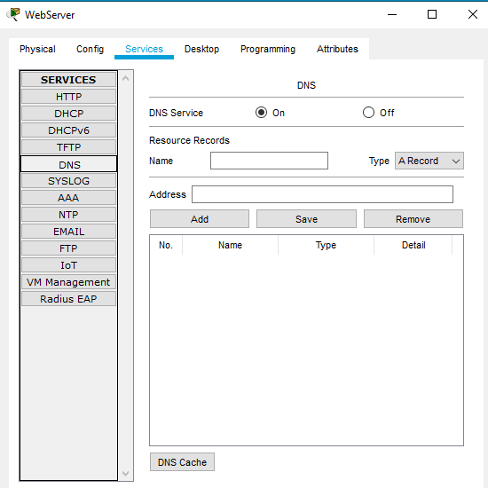  Replace the snip on the left with the DNS section of the WebServer | 2

- From the Network Laptop, attempt to ping any of the resources assigned “A” records in DNS using the created name | Points Possible | Points Awarded
Replace this shape with a snip from the Network Laptop of a successful ping of a resource using the DNS name. | 1

- Configure the Admin Switch for telnet access. Take any other steps required to have a relatively secure switch (passwords, line configurations, console configurations) | Points Possible | Points Awarded
Replace this shape with a snip from the Network Laptop of a telnet session with the AdminSwitch. In the session, display the portion of the running configuration dealing with vty configurations. | 2

Total Possible Points | Total Points
20

